**WHAT IS THE PURPOSE OF A LIBRARY MANAGEMENT SYSTEM?**

**The purpose of a library management system is to operate a library with efficiency and at reduced costs. The system being entirely automated streamlines all the tasks involved in operations of the library. The activities of book purchasing, cataloging, indexing, circulation recording and stock checking are done by the software. Such software eliminates the need for repetitive manual work and minimizes the chances of errors.  
  
The library management system software helps in reducing operational costs. Managing a library manually is labor intensive and an immense amount of paperwork is involved. An automated system reduces the need for manpower and stationery. This leads to lower operational costs.  
  
The system saves time for both the user and the librarian. With just a click the user can search for the books available in the library. The librarian can answer queries with ease regarding the availability of books. Adding, removing or editing the database is a simple process. Adding new members or cancelling existing memberships can be done with ease.  
  
Stock checking and verification of books in the library can be done within a few hours. The automated system saves a considerable amount of time as opposed to the manual system.  
  
The library management system software makes the library a smart one by organizing the books systematically by author, title and subject. This enables users to search for books quickly and effortlessly.  
  
Students need access to authentic information. An advanced organized library is an integral part of any educational institution. In this digital age a web based library management system would be ideal for students who can access the library’s database on their smartphones.**



**2. HOW DO YOU DESIGN A LIBRARYMANAGEMENT SYSTEM?**

**Library management systems are designed to manage the movement of books and maintain records of the members in a library. The software solution is designed based on the system requirements, the people involved, the content of the operation and the activity to be performed.  
  
The system requirement in library management focuses on the possibility of search for books by title, author or subject by the member. They should be able to locate a book physically by the unique identification code and the rack number for each book. The system should provide details on the books held by the members. The system should limit the number of books that can be taken and the number of days that a book can be kept for. The system should generate fines when due from the member.**

**The next step focuses on the functions of the librarian, the member and the system. Managing books by the librarian, searching for books by the members and notifications sent by the system are detailed in a case diagram.  
  
The third step in the design of the library management system software is based on the different aspects of a library. The name of the library, the book details, member details, membership cards, book reservations, book lending, cataloging, fines, book racks and notifications are consolidated as a class diagram.  
  
The next step further breaks down the functions into specific activities that are performed in a library. An activity diagram based on the primary activities – checking out a book, returning a book and renewing a book – is drawn.  
  
The final stage is coding for each activity in the case, class and activity diagrams. This is the most important function in the design of the library management system software.  
  
Library management system gitHub, the software created using Python, stores data on a log file. The software systems are developed on this platform.**



**3. WHAT SYSTEM DOES A LIBRARY USE?**

**The library management system software should be user-friendly and cost effective. It should be in tune with the establishment’s needs and compatible with the existing technology.  
  
  
A library should use a software system that helps in effectively managing the data in a library. The library database includes all relevant information regarding assets to membership details. The software records details on all reading and reference material available for reading and lending. Membership information, lending details and renewal dates are managed by the software.  
  
  
A library management system software with capabilities of barcoding and RFID helps in scanning the barcode while lending or returning books. Management of the catalogue and inventory by the system makes the process accountable.  
  
  
The feature of the software assists in inventory and**[**circulation management**](https://en.wikipedia.org/wiki/Library_circulation)**of the books. Books in stock, on the shelves, in circulation, missing or to be ordered can be tracked by the system. Acquiring new assets becomes easier with the software.**



**4. HOW DO YOU MANAGE A LIBRARY?**

**Managing a library requires knowledge of library management and skills to perform the activities. The task involves planning, decision making, organizing, collecting and disbursing information and controlling and monitoring the various functions.  
  
The management should have an objective for running the library. They should have a clear idea of the members they wish to serve. The selection of books in different categories is dependent on the interests of the members.**

**An understanding of the organizational hierarchy will enable proper delegation of responsibilities to the personnel employed. Governmental regulations regarding structure, space and systems should be in place.  
  
A budget has to be allocated for the operation of the library. Maintenance of the library has to be scheduled on a regular basis. Dusting, cleaning, pest control, exposure to air and sunlight, replacement of fixtures are essential in preserving the library.  
  
A proper inventory check has to be done annually to record the details of books in circulation. Provisions for the replacements have to be done accordingly.  
  
These are the basics for operating a library efficiently. In a traditional library all these functions were done manually by people. The process was time consuming and expensive. In today’s digital world software solutions have been developed for library management. This system performs all the adequate functions with increased efficiency and accuracy saving time and costs.  
  
Library management software system makes the primary functions of adding and deleting, issuing and returning of books very simple. The processes of book indexing, cataloging, book reservations and overdue notifications are automated. The software system makes the process simpler and more accountable.**



**THE MAIN CLASSES OF OUR LIBRARY MANAGEMENT:**

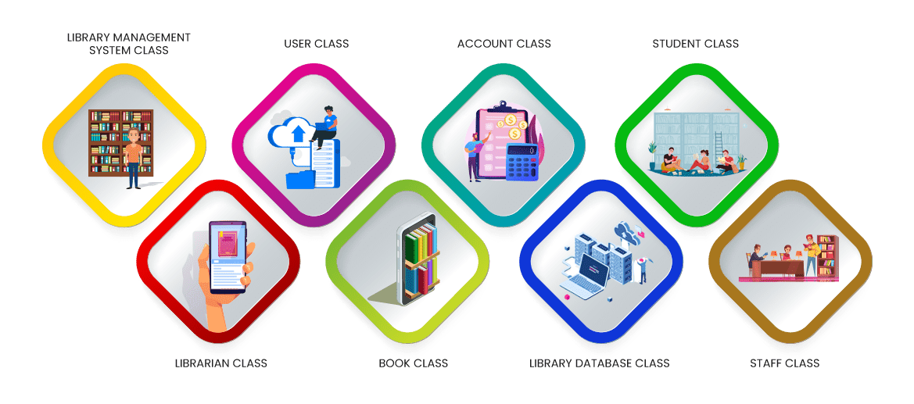

**The library management system software is based on the different sections or classes involved in the operation of a library. The functions and attributes of the classes and relationships between them are specified in a Class Diagram. This diagram forms the fundamental step in building the management software.**

**Library management system class:**

**This class manages the entire library management functions and is the focal point on which the software is designed. The attributes of User type and User name with the functions of Register, Login and Logout are vital to any web based library management system.**

**Librarian class:**

**This class manages all the operations of the Librarian. The name, ID and respective password for the librarian are verified. The search string used by them in searching for books is saved for future use.**

**User class:**

**The operations of the user are managed by this class. Name and ID of the user is verified. Information on the books accessed by each user is recorded.**

**Book class:**

**All operations pertaining to the books are managed by this class. Books are classified on the attributes of title, author, subject and date of publication.**

**Account class:**

**Accounting functions are dealt with by this class. This class keeps track of the borrowed books, reserved books, returned books, lost or missing books and the fine amounts due.**

**Library database class:**

**The database of the library is controlled by this class. The list of books are classified and managed for easy search by this function. Books can be added, deleted, updated and displayed in the library management system software.**

**Student class:**

**The operations of the students are managed by this class. Books pertaining to the age and grade of the students are classified and frequently used books are saved for later reference.**

**Staff class:**

**The operations of the staff are monitored by this class. Department wise functions are detailed and periodic checks are made.**

**CHECK-LIST FOR SELECTING A LIBRARY MANAGEMENT SYSTEM:**

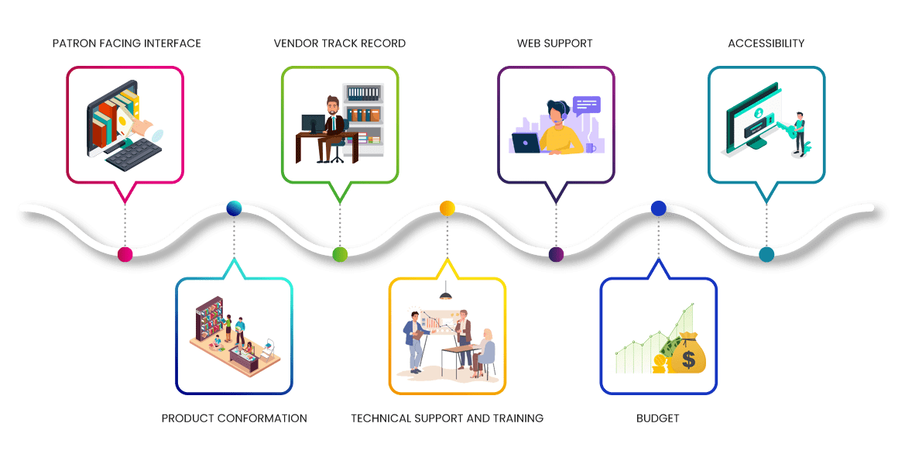

**The selection of the library management system software depends on the type of library that needs to be automated. Libraries can belong to a school or college, public libraries for the community or specialized libraries for specific industries. Each type of library has different requirements to cater to their patrons.  
The size of the collection of books, the type of library, the budget, the staff size and the compatibility of the system with working partners have to be considered when selecting a software system.**

***Patron facing interface*:**

**The objective of a library is to help the patrons to find the right book. These interfaces with other tools allow patrons to search for what they want. The system should have filtering options for older users and easy to use icons for the younger users. Patron facing tools include the useful features of reservation of books, displays and notifications. The browse feature permits the user to search for books of interest by topic, genre or author.**

***Product conformation*:**

**The library management system software has to be one that can manage the entire work of the library. The software should be flexible to suit the needs of the library. Primarily the work of the librarian and that of the other staff have to be addressed by the system. The system has to be user friendly and customizable to each user – the librarian, the borrower or user, accountant and other staff. The items, labels, reports and preferences should be free to choose from.**

***Vendor track record*:**

**The library has to do a check of the vendor and his capabilities prior to buying. The provider has to demonstrate the product to the users. The vendor has to install the library management system software on the computers in the library.**

***Technical support and training*:**

**The provider should be able to train the end users to competently operate the system. They have to ensure prompt service for technical hitches that might occur. Training for the staff has to be provided when the software is updated.**

***Web support*:**

**There are different types of library software. The installed system should be supported by the web. A web based library management system is the most ideal as it provides extensive coverage of books, journals, reference resources.**

***Accessibility*:**

**The system should allow the school libraries to manage their student base from a central system accessible from anywhere, anytime. It should be possible for management to view the library operations from anywhere. The program should be accessible from libraries, classrooms, computer labs, homes and any place with an internet connection or web access.**

***Budget*:**

**The cost of the library management system software depends on the features it offers. It is best to list out exactly what functions have to be managed to reduce the cost of purchase.**

* **BEST LIBRARY AUTOMATION SOFTWARE:**



**Library automation is the process of automation of the functions of a library using a computer. The best library automation software helps in digitally transforming the library and making it accessible to all.  
  
The critical functions of cataloging and circulation of books is done automatically by the library management system software. Entry of new books, deletion of old books and updating of the member and book database becomes simple. The books borrowed, returned, lost or misplaced can be tracked by the system.  
  
The membership details are recorded in the system.Overdue fines are calculated automatically and notifications are sent to the defaulters.**

***Purpose of automation software*:**

**In a traditional library the details of the members and the books in the library are recorded manually. The date of issue and return of books, overdue books, fines accrued are all entered in registers by the librarian and his assistants.  
  
The library management system software records all this data automatically by RFID sensors reading the barcodes. This saves time, effort and money. The librarian’s work becomes less tiresome. The automatic process reduces the chance of errors thereby increasing the accuracy of the records. The user friendly interface increases member engagement and improves the efficiency of the library.  
  
A web based library management system enables the librarian and the patrons to access the library from anywhere at one’s convenience. The software encompasses a whole gamut of functions which exposes the users to a wider collection of reading material.**

***Different types of libraries*:**

**Academic libraries are those associated with schools, colleges and universities. Special libraries cater to specific groups of people like members of a department or research organization. Public libraries are accessible by the general public in cities and towns. The National library of a country serves as a storehouse of the literature of the country.**

***Why is automation critical to the education industry ?***

**A typical library in a school, college or university is a collection of books, periodicals, journals and reference books. It is the duty of the librarian to keep the educational material in a systematic and organized way so that teachers and students can access the required content at the right time.  
  
Library management system software automatically organizes the books by categories, subject, author, topic, and maintains the records with ease. The web based software enables teachers and pupils to search for books at any time from any place.  
  
Updating the extensive database, adding or deleting books or editing the records can be done faster by the library staff and with more accuracy. The tracking of books becomes an effortless task.**

***Challenges faced by non automated libraries :***

**Manual handling of a vast collection of reading material is tough and tedious for a librarian. It requires a lot of effort and is time consuming for the librarian to manage a non-automated library with efficiency.  
  
Manually entering the details of issue of books, return of books, the date of borrowing and return, calculation of fines, collection of dues can be tiresome. The chance of errors is high. Tracking of books in circulation and tracing lost or misplaced books become cumbersome.  
  
Managing a non-automated library is time consuming and laborious. More than one staff would be required to man the library increasing the cost of operation. The librarian will not be able to help the patrons satisfactorily.**

**ADVANTAGES OF LIBRARY MANAGEMENT SYSTEM SOFTWARE**

**User friendly system:**

**The library management systems are simple and easy to use for the librarian as well as the students. The system provides online and offline storage of data. The system automatically updates and backups data. The system is flexible and can be adapted to the needs of the institution.**

**Simplification of librarian duties:**

**The system allows the librarian to maintain a wide collection of books, periodicals, journals, audio and video books and pictorials. The librarian operations of addition and deletion of books, tracking books, tracing missing books, reserving books can be performed very easily.**

**Increased member engagement:**

**The web based library management system software can be easily accessed from anywhere and at any time. The members can search for books from classrooms, computer labs, home and places where the internet is available. The system provides access from smartphones and tablets to search books and resources. The easy access increases engagement of the users.**

**Efficient data management:**

**The library management system software hosted from a cloud platform is very efficient. The functions of cataloging, indexing, referencing and circulation of books are managed automatically and saved on the cloud for reliable and secure operations.**

**Time and effort saver:**

**The automated library system software eliminates the need for manual entries. This saves the effort and time consumed in data entry. Automation makes the database error free and accurate.**

**Automated reports:**

**The system reports the performance of the library automatically. Charts and graphs are provided for review and tracking of the library functions. This aids in making changes and improvements to the library.**

**Cost effective*:***

**Digital libraries eliminate the need for extensive paperwork and too many staff. Maintenance overheads and operation costs are reduced.**

**FEATURES OF LIBRARY MANAGEMENT SYSTEM SOFTWARE:**

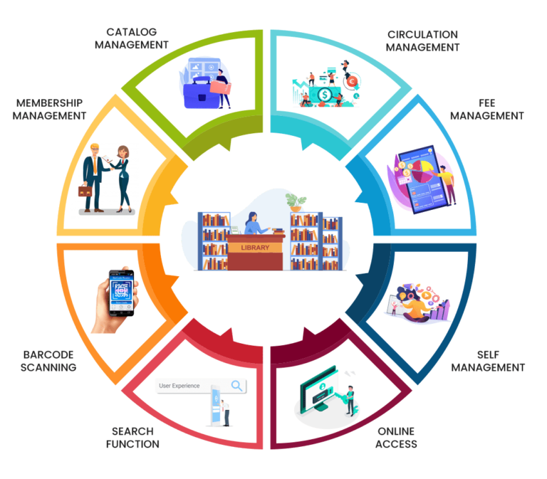

The best library management system software will have the following features:

**Catalog management:**

to digitally keep track of what is available in the library. The books will be catalogued by title, subject, author and date of publishing.

**Membership management:**

to maintain a detailed database of the members. The system records the name, ID and password of each user. The system helps in ascertaining the track record of the member.

**Circulation management:**

to track the movement of books. The location of any book at any point of time can be tracked. Misplaced or missing books can be traced with ease. The details on books to be returned and that which are overdue for return are provided on a daily basis.

**Acquisition management:**

to acquire new books and add them digitally. Irrelevant and outdated books are deleted.

**Bar-coding:**

to give specific identification to each book. All books, old and new, are bar-coded on the basis of title, author, topic and date of publishing.

**Barcode scanning**

to read the barcode easily using RFID sensors. The database is automatically updated when books are scanned while issuing or returning.

**Search function:**

to enable both the librarian and the members to search the catalog of books in the library. The search functions can be filtered to the need of each user.

**Online access:**

to catalogues of other public libraries. The web based library management system software provides access to different associate libraries. This broadens the spectrum of search benefitting the user considerably.

**Self management:**

to check in and check out books by oneself. The library management system software of digital libraries allows the members to login, search, select, issue and return books by themselves.

**Fee management:**

to collect membership fees and manage individual member accounts. The software calculates the fine due for non-return or lost and damaged books. The members are intimated of the fines by the system.

**DIFFERENT TYPES OF LIBRARY MANAGEMENT SOFTWARE:**

**CodeAchi Library Management System**

1. 1.Manages acquisition of books, add titles, and controls the inventory
2. 2.Enables search using ISBNs
3. 3.Assigns an accession number automatically making cataloging easy.
4. 4.Accommodates all media- print and digital content including DVDs, CDs, Blurays, comic books
5. 5.Adds members to the database and prints library cards.
6. 6.Records issue and return of books, payments and tracks lost books
7. **7.Library management system software**supports Barcode and QR code scanning.
8. Link: [http://www.Crack4Windows.com](http://www.crack4windows.com/codeachi)
9. [/codeachi](http://www.crack4windows.com/codeachi)

**LibrarySoft**

1. 1.Manages circulation of the books
2. 2.Newly acquired books can be catalogued easily.
3. 3.Supports Barcode and RFID scanners.
4. 4.System supports Online Public Access Catalog (OPAC)
5. 5.Can be used by School libraries, Public libraries and Private Institutional
6. 6.Books can be reserved by the Reserve Shelf Management Feature.
7. 7.Fee collection feature records payments, calculates fines, issues receipts and sends reminders.
8. 8.The **library management system software** is Web based and cloud platforms
9. 9.Operates on Mac, Windows and Android systems
10. Link: [http://librarysoft.in](http://librarysoft.in/)

**GLibrary – Library Management Software**

1. 1.Circulation feature provides information on issue/renewal/ return of books.
2. 2.The acquisition and bulk uploading of books can be done quickly and easily.
3. 3.Bar codes can be generated and scanned for faster transactions.
4. 4.The cataloging system supports OPAC for quick and easy search of books from anywhere.
5. 5.Fine collection feature allows automatic charging for overdue books.
6. 6.The software can be accessed with a mobile app and can be used by multi-users.
7. Link: [http://glibrary.gayatrisoft.co](http://glibrary.gayatrisoft.co/)

**eLIBRARY Library Management System**

* 1. 1.Cataloging and classification can be done based on author, title and subject.
  2. 2.Membership management keeps track of the user members name, ID, passwords
  3. 3.Circulation management records the movement of books in the library.
  4. 4.Acquisition function selects and purchases resources for the library.
  5. 5.Web based Online Public Access Catalog provides access for search of books.
  6. 6.Automatic reporting system generates transaction, book status, fee reports etc.
  7. **7.**The **library management system software** supports Barcode and RFID.
  8. Link: [http://elibrarysoftware.com](http://elibrarysoftware.com/)

**SLiMS – SENAYAN Library Management System**

1. 1.Catalog/bibliographic management with book search and cover image support.
2. 2.Circulation support for issue, renew, return and loss of books.
3. 3.Membership management for record of member data.
4. 4.Online Public Access Catalog with simple and advance search modes.
5. 5.System supports digital contents –PDF, PPT, Audio, Video etc.
6. 6.Database management supports bar code generation and reading.
7. **7.**Reporting feature generates the upto date statistics and status of the operations.
8. Link: <https://slims.web.id/web>

**Oliver v5**

1. 1.This software primarily caters to school libraries – Preparatory to Secondary
2. 2.Fully web based software can be accessed from desktop and tablet devices 24/7
3. 3.Book acquisition and inventory checks are managed.
4. 4.Bar code and RFID are supported by the system.
5. 5.Book movement is managed by the circulation feature.
6. 6.Online Public Access Catalog allows search and book reservation.
7. 7.Self check-in and check-out is possible.
8. 8.Fee collection feature enables members to be reminded of charges due.
9. Link: [http://glibrary.gayatrisoft.co](http://glibrary.gayatrisoft.co/)